 |  | 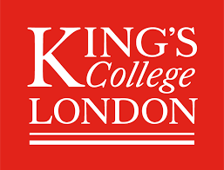
Integrated Clinical Academic Schemes 2024-2025
Letter of employer support
Please ensure that this form is completed by your senior line manager. This form needs to be submitted to lsbushortcourses@lsbu.ac.uk with ‘London_NHSE_ICA’ in the Subject. Please click the link in your confirmation email to submit. Your confirmation email is generated on submission of our online application form.
Name of applicant:
Name of line manager:
Employer/ Trust name:
Line manager telephone number: | Line manager email address:

Please confirm the following statements:
- I am aware that the above-named individual has applied for the NHS England (NHSE) Integrated Clinical Academic Schemes for non-medical healthcare professionals across run by LSBU and King’s.
- I understand our organisation will receive a one off training allowance contribution of £10,500 if the applicant is successful.
- I understand that the training allowance will be paid via the existing Education Contract already included in the contract funding from NHS England and is to be accessed through the Education Department held with each employing NHS Trust.
- I understand that I need to contact the finance department of my Trust to draw down the funding internally
- I confirm that the above named applicant will be released from their clinical obligations to attend the scheduled scheme activities. Successful applicants are normally entitled to a maximum of two-day per-week (or equivalent) secondment, throughout the duration of the scheme, to engage in clinical activities to support their research development.
- I confirm the applicant will also receive mentorship from a senior colleague within our organisation and will be provided access to other learning opportunities to promote their development as a clinical academic.
Line manager signature: | Date:

